# PROJECT I

## REPORT: Analytics of Blackwell’s Retail Sales Numbers

In this article the subject is on having a deeper understanding of the company’s customer behaviours by different perspectives. Recently launched website is an additional source of data and a new field where further developments could be in action in the near future. ­

Firstly, we should answer the question whether the company should invest more into the e-commerce business. By that we can examine the questions coming from the management, namely the topics are

1. Deep analysis of the Regions
2. Grouping customers by Age
3. Correlation between number of items and the amount of transactions
4. One more hypothesis coming from the VP of Sales should be investigated: “*customers who shop in the store are older than customers who shop online and that older people spend more money on electronics than younger people.”*

* From the given excel file I interpreted the data as per month and the revenue as USD currency.

## Grouping customers by different

The exact locations are unknown. The number of the customers will not tell us any further information about the region. Profitability and the number of transactions also depend on the largeness of the territory, the number of the small and big cities, retails shops in the given region. Easy to tell the biggest market by the number of customers and both in revenue perspective is the Region 4. It is important to highlight that from the total revenue, **Region 4 is sharing half of the market.** Needless to say, number 4 is a key region for the company.

Let’s start comparing the Number of customers and the relevant revenue for each region.

* Region I: Overall there are more costumers shopping in the stores than online. The number of the customers and their expenses are directly proportional. Comparing the **number of customers** (and also understandably the revenue) to the other regions **they are significantly falling short.** The company should investigate what is the background for the low number. It might be the age factor – which I will check later – or any other demographic factor, wrong marketing campaign etc.
* Region II: This region might not have physical stores, and only the website available for the customers, this can explain why customers only purchased online. **Relatively, this region has high number of customers, but the revenue is not outlier**. Also, if we see the average spending of 1 particular customer is lowest in the whole area. We shall investigate this region as well which factor can be for this reason: number of items, age, etc.
* Region III: Interesting to see that there are more costumers in stores than online but from revenue perspective online has a better ratio. The rates for number of customers and revenue are reverse.
* Region IV: As the previous region online revenue is still higher than the instore income. Additionally, **number 4 is one of the best performance regions in the area.** We shall investigate and understand the good pattern of this region to follow the good example.

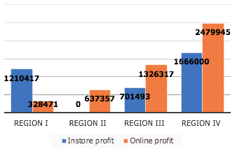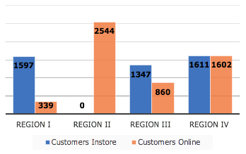

**Description Region I Region II Region III Region IV SUMMARY**

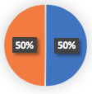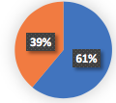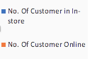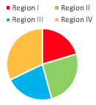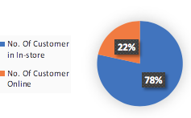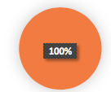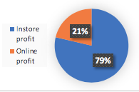

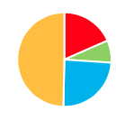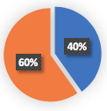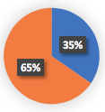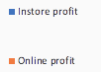

|  |  |  |  |  |  |
| --- | --- | --- | --- | --- | --- |
| Average No. Costumer | 756 | 251 | 919 | 1290 | 2597 |
| Average Cost of Item | 166 | 55 | 206 | 288 | 185 |
| Average Age | 45 | 57 | 45 | 38 | 45 |
| Average No. Item | 4,5 | 4,5 | 4,4 | 4,4 | 4,5 |

## Grouping customers by different labels

Discretising the age to the following group to ensure we can see any pattern: Young (18-34), Adult (35-51), Senior (52-67), Retired (68+). Also, we did the same way with the revenues: Low (0-1003), Middle (1004-2001), Upper (2002+).

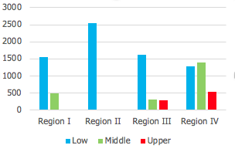In overall the majority of the costumers are in the group of young or adult. This is also correlate with the higher revenue.

Seeing region IV where most of the customers are labelled for the younger group has Middle or Upper revenue base.

Surprisingly where no physical stores are available – in region II – there are less Young people and actually the biggest number of the Retired people in the whole area. On the other hand, this region only has low revenue base which we should investigate if it in general and it applies for online purchasing or just specifically valid for this region.

Pulling together all the regions I would analyse the revenue groups by the different age groups. Retired people are not spending too much comparing to the other groups. According to data the company should focus on the 18-34 and the 35-50 ages.

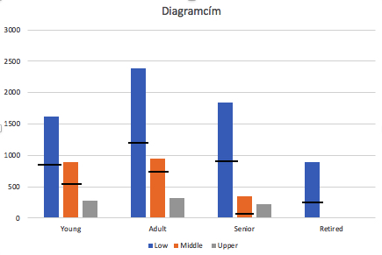Selecting the age groups, we can examine how much they spent it total. The last diagram shows the rate of the onsite and online purchase – under the black line is from the stores. **The Upper revenue is coming exclusively from the online purchase** which also bring us to the next topic.

Before we get there I also examined if there is any connection between the revenue and the number of the items. It turned out there is no important coherence. Only one alluring fact coming out that who buys 1 or 8 item(s) spend less than who buy between 2-7.

## CONCLUSION

Heading back to the statement from the VP of Sales: “customers who shop in the store are older than customers who shop online and that older people spend more money on electronics than younger people.”

Is might be wrong: customers who shop online is not obviously older. In fact, older people use online option more frequently than we might actually think and spend less than younger people.

The target costumer in all regions are the youngers and the company should continue to invest in the e-commerce business.